Resync

User Manual
Team - 57

What is Resync?

Resync is a video application that lets users create videos of themselves with their lips movement synced with sound dubbed from any famous movie, quote, song lyrics, etc. All you have to do is to select a sound and a video either from the library or from your device. Once you are done, you can download the clip on your smartphone or can share on social media platforms like Facebook and Instagram.

How to Get and Set Up Resync

Resync is a free mobile device application. You can’t use it on your computer. Head over to the App Store, Google Play, or Marketplace and download the Resync app. There is no registration or login.

Selecting Sound
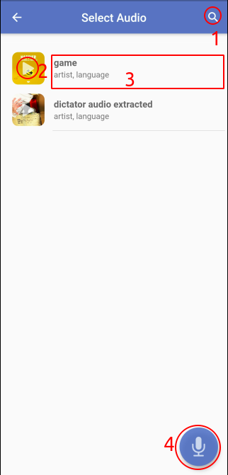
For creating your video, the first thing you’ll need is a sound. You can select(3) a sound from the sound library by Resync.You can play(2) the audio before selecting it. You can also search(1) for a sound of a particular dialogue or song lyrics. You can refresh the library by swiping down. If you didn’t find any desired sound then you can record(4) one by yourself . You can record upto 30 seconds.You can start/pause(5) recording. You can stop the recording by the side stop(7) button. The timer(6) at the top displayed the recording duration. You can play(8) the recorded audio or discard(9) it or select it(10).
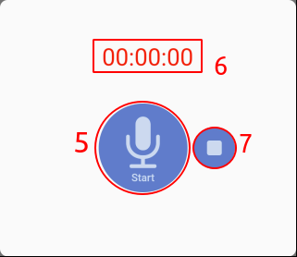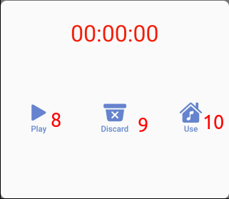

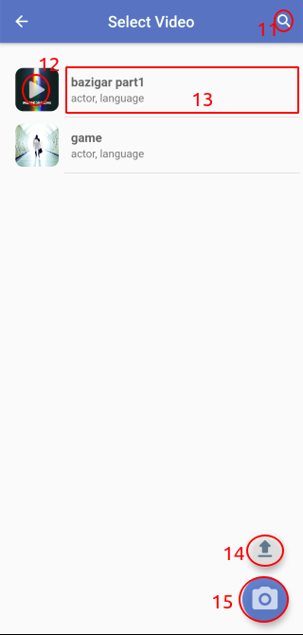
Selecting Video

After finalizing the sound, it’s time to select(13) a video. You can find the video library by Resync with faces from around the globe. You can check out a video clip by playing(12) it before selecting. You can also search(11) for a video of a particular person by their name. You can also record(15) a video by yourself upto 30 seconds. The recording interface will be provided by your native camera application. You can also upload(15) a video from your device upto 2 MB of size.

Preview
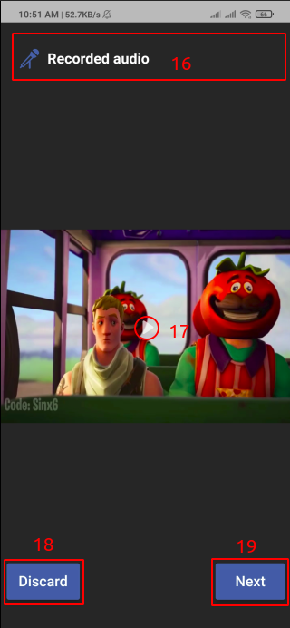
After selecting a sound and a video, you can play(17( both the sound and the video together to get a glimpse of the duration of the final video. You can play/pause it by clicking on the video. If you want to change the sound you do not need to go back, you can click on the sound clip name (16) which takes you back to the sound library. If you want to change the video, you can discard it by clicking on discard(18) or navigating back to the previous screen. After finalizing the sound and the video, you can click next(19) to generate a lip sync video.

Sharing or downloading lip-synced video
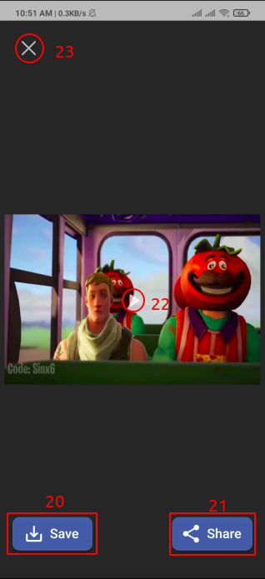
Once your lip-synced video is ready, you can play(22) the video by clicking on it.You can save(20) it to your device or share(21) it with your friends/followers on Facebook or Instagram or any other social media platform. You can discard(23) the video and create another one with the same set of sound and video or change them.

